Standards of attainment: Key Stage 1 and 2
District analysis.
Standards overall (combined R/W/M) rose last year by 2.5% to 63.4% (63%). This was however below the national average of 63.7%.
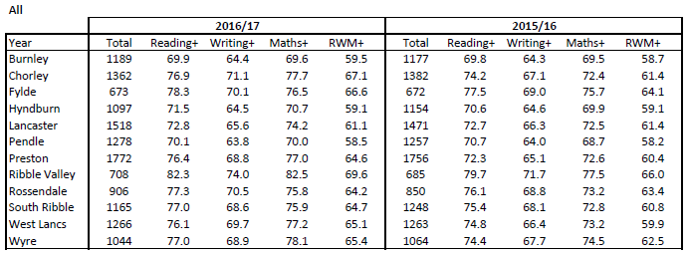
Burnley
The number of pupils who attained the expected standard in the core subjects of reading, writing and mathematics (combined R/W/M) was 59.5%, a rise of 0.8% which is less than the Lancashire average. Burnley was the third lowest attaining district, now 3.9% below the LA average, and 4.2% below the national average. Attainment in each of core subjects are also below the Lancashire average, with very modest rises. The gap overall and by each subject individually has grown.
Hyndburn
The number of pupils who attained the expected standard in combined R/W/M was 59.1%, in line with last year. Hyndburn was the second lowest attaining district in Lancashire, at KS1. With a 0% rise, the gap between Hyndburn and the authority grew to 4.3% below the LA average, and 4.6% below the national average. Standards rose slightly in reading and maths, and fell by 0.1% in writing.
Pendle
The number of pupils who attained the expected standard in combined R/W/M was 58.5%, a rise of 0.3% from last year. Pendle remains was the lowest attaining district, and the gap has widened to being 4.9% below the LA average. There was a rise in mathematics, but a fall in reading and writing. Attainment in each of the core subjects was below the Lancashire average.
Rossendale
The number of pupils who attained the expected standard in combined R/W/M was: 64.2%, a rise of 0.8%. Attainment was 0.8% above the LA average (63.4%). There were rises in reading, writing and mathematics, and attainment in each core subject is above the Lancashire average.

Lancaster
The number of pupils who attained the expected standard in combined R/W/M was 61.1%, a slight fall of 0.3 which represents the only fall across a district. Attainment was the 5th lowest in the authority and 2.6% below the national average. Attainment fell in writing and there were small gains in reading and mathematics. Attainment is below the Lancashire average in all core subjects.
Fylde
The number of pupils who attained the expected standard in combined R/W/M was 66.6%, a rise of 2.5%. Attainment was the 3rd highest in the authority, 3.2% above the LA average (63.4%). Standards rose in all core subjects, and are above the Lancashire average in each subject. However, the rate of improvement in all core subjects was less than that across Lancashire.
Preston
The number of pupils who attained the expected standard in combined R/W/M was 64.6%, a rise of 4.2%. Attainment grew at a faster rate than that in Lancashire, so standards are now 1.2% above the LA average (63.4%). Standards also grew in each core subject by some 2%, and are above the Lancashire average.
South Ribble
The number of pupils who attained the expected standard in combined R/W/M was 64.7%, a rise of 3.9% and a greater rise than that in Lancashire. Attainment was 1.5% above the LA average (63.4%). Attainment was above the Lancashire average in each subject, with rises in all core subjects.
West Lancs
The number of pupils who attained the expected standard in combined R/W/M was 65.1%, a 5.2% rise, double the Lancashire average. Consequently, standards are now above the Lancashire average. Attainment was the 5th highest performing district. Attainment rose in each core subjects, in particular in mathematics (+4%).
Chorley
The number of pupils who attained the expected standard in combined R/W/M was 67.1% a rise of 5.5%, and remaining above the Lancashire average. Standards rose in each core subject, including mathematics (+5.3%). Standards remain above the LA average in each of the core subjects.

Key Stage 2
Attainment in all core subjects combined was 60.5%. In reading, the number of children who reached the expected standard in reading was 70.5%, a rise of 5.1%. This was in line with the national average of 71%. The number of children who reached the expected standard in writing was 76.9%. This represents a fall from 2016 of 0.6% when 77.5% of children reached this standard. This remains above the national average of 76%. The number of children who reached the expected standard in mathematics was 75.1%, a 5.1% rise from last year. This was in line with the national average of 75%.
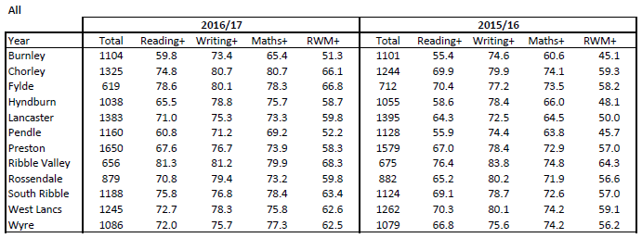
Overall attainment, as measured by the number of children attaining the expected standards in each of reading, writing and mathematics was 60.5%. District attainment retains some of the usual features. The highest performing district in 2017 was the Ribble Valley, as in previous years. This is followed by Chorley and the Fylde. The lowest performing districts were Pendle, Burnley and Hyndburn. The rise in Lancashire was 6%. Contained within this are some significant rises:
- Hyndburn: a rise of 10.6%
- Lancaster: a rise of 9.8%
- Fylde: a rise of 8.6%
- Both Burnley and Pendle had a rise above the Lancashire average.
The lowest rises were in Preston (+1.3%), Rossendale (+3.2%) and West Lancashire (+3.5%).
Burnley
The number of pupils who attained the expected standard in combined R/W/M was 51.3%, a rise of 6.2%. Burnley is now the lowest attaining district, 9.0% below the LA average, and 9.7% below the national average. Attainment in each subject was also below the Lancashire average.
Hyndburn
The number of pupils who attained the expected standard in combined R/W/M was 58.7%, a rise of 10.6%, and now much closer to the Lancashire average (60.5%). Hyndburn is now the 4th lowest attaining district, but with a much reduced gap. Attainment in reading and mathematics was rose by approximately 9%. Standards in Hyndburn are above the Lancashire average in both writing and mathematics.
Pendle
The number of pupils who attained the expected standard in combined R/W/M was 52.2%, a rise of 7.5%. This rate of improvement was above that of Lancashire. Pendle was the second lowest attaining district, 8.3% below the LA average (60.5%). Standards went up by approximately 5% in reading and writing, but fell by 3% in writing. Attainment in each subject was also below the Lancashire average, particularly in reading (10.6%) and mathematics (7.6%).
Ribble Valley
The number of pupils who attained the expected standard in combined R/W/M was 68.3%, a rise of 4%. Attainment remains the highest in the authority, 8.5% above the LA average, although this represents a lower rate of improvement. Attainment was also above the Lancashire average in each subject.
Rossendale
The number of pupils who attained the expected standard in combined R/W/M was 59.8%, a rise of 3.2%. Attainment last year was 0.7% below the LA average, and 1.2% below the national average. Attainment in reading rose by over 5%, but there was a modest 1.3% rise in mathematics (vs 4.8% across all districts).
Lancaster
The number of pupils who attained the expected standard in combined R/W/M was 59.8% a rise of 9.8% from 50% in 2016. The rise in standards was well above that of Lancashire of 6%, but attainment remains below the Lancashire average of 60.5%. Attainment rose in all three subjects, most noticeably by 8% in mathematics.
Fylde
The number of pupils who attained the expected standard in combined R/W/M was 66.8%, a rise of 8.6%. This rate of improvement was above the LA and so attainment is now the 2nd highest in the authority, 6.3% above the LA average, and 5.8% above the national average. Attainment was above the Lancashire average in each of writing, reading and mathematics, with rises in all core subjects.
Wyre
The number of pupils who attained the expected standard in combined R/W/M was 62.5%, a rise of 6.3% and above the LA average (60.5%). Attainment rose in each core subject. Standards are above the Lancashire average in reading and mathematics, but below in writing.
Preston
The number of pupils who attained the expected standard in combined R/W/M was 58.3% a rise of 1.3%, below the Lancashire rise of 6%. Attainment is now 2.2% below the LA average, and 2.7% below the national average. Attainment is also below the Lancashire average in each subject. There was a modest rise in reading, but a decline in writing and mathematics.
South Ribble
The number of pupils who attained the expected standard in combined R/W/M was 63.4%, a rise of 6.6%. Standards are now above the Lancashire average of 60.5%. Attainment was above the Lancashire average in all core subjects.
West Lancs
The number of pupils who attained the expected standard in combined R/W/M was 62.6%, a 3.5% from last year (59.1%), and remaining above the Lancashire average (60.5%). Attainment rose in reading and mathematics, but there was a 1.8% drop in writing. Attainment remains above the Lancashire average in each core subject.
Chorley
The number of pupils who attained the expected standard in combined R/W/M was 66.1, a rise of 7.4% from last year, above the Lancashire average. There were rises in all core subjects, which remain above the Lancashire average.

